TIVERTON CIVIC
SOCIETY
NEWSLETTER
TIVERTON CIVIC
SOCIETY
NEWSLETTER

TIVERTON CIVIC
SOCIETY
NEWSLETTER

Reg. Charity 1043675 No. 91 October 2019

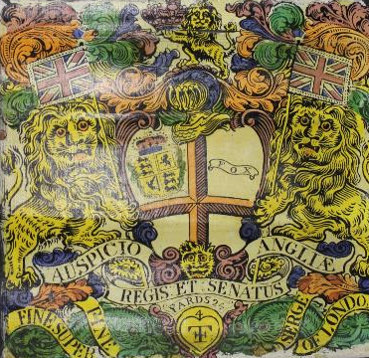

A Tillet Cloth in the Wool Trade Gallery at Tiverton Museum

CONTENTS Page

Chairman’s Introduction, Jeremy Salter 3
Allies Mid Devon, Amanda Davies 5
Two Tiverton Manors recorded in the Domesday Book, Fern Clarke 8
The Stické Tennis Court at Knightshayes, Jeremy Salter 14
Significant Donations to the Museum, Pippa Griffith 15
Exploring Significant Multicultural Histories in Tiverton, Lizzie Mee 18
Neil Ghosh and the Jewel in the Crown, Jeremy Salter 21
Lorna Doone 150 years on, Fern Clarke 25
Restoration of the Greenway Chapel, St. Peter’s Church, Bill Zarrett 30
_______________________________________________________________
Committee Members and Members with Special Responsibilities

Janet Rendle President
Jeremy Salter Chairman, website manager & planning
Dennis Knowles Vice Chairman
Matthew Melksham Hon. Treasurer
Fern Clarke Hon. Secretary, planning & newsletter editor
Randall Thane Membership Secretary
Alison Gordon Outings Organiser
Anne Davies Heritage Open Days, walks and refreshments
Mike Sanderson Planning; link to CPRE
Mary Cross, Frank Connock, John Rendle, Andrea Rowe,

Contact for membership enquiries: randallthane@gmail.com / 01884 258389
Our thanks to Pippa Griffith for the front cover photograph, and to Fax and Files for printing this newsletter.
Chairman’s Introduction
This is a shorter chairman’s introduction than usual - it is gratifying that contributors have submitted so much interesting material for this newsletter. The article by Amanda Davies is further evidence of the great desire of many people to improve our community, while that by Lizzie Mee highlights a fascinating project to celebrate Tiverton’s multicultural history, and Bill Zarrett outlines the restoration of what is perhaps Tiverton’s most remarkable building, described by Nikolaus Pevsner as ‘a gorgeously ostentatious display of civic pride’. Fern Clarke’s article on Lorna Doone neatly complements Mike Sampson’s excellent talk to the society in June, while she also introduces a forthcoming series of articles on Collipriest House. Pippa Griffith once again demonstrates the growing quality of our superb museum.
The environment has rapidly risen to the top of the political agenda and we welcome Mid Devon District Council’s bold decision to aim for Mid Devon to become carbon neutral by 2030, ‘all decisions made by the council being considered in light of the climate crisis’. We hope that this will be acted on robustly, for instance in the design of new housing, and, also, that more stringent targets are introduced as soon as possible to prevent the appalling health problems which can be created by toxic emissions. No level is a safe level, even small towns like Tiverton are not free of potential problem areas, and pollution levels must always be taken considered when major planning applications come forward. As recently suggested in parliament, a good start would be to introduce the stricter standards nationally, recommended by the World Health Organisation, which would require every post code to be monitored.
Over the past two years we have, in competitions organised by Historic England and Civic Voice, been very successful in highlighting the attractions and importance of the Tiverton Conservation Area. This year we have nominated the Grand Western Canal Conservation Area in the competition organised by Civic Voice to find ‘England’s Favourite Conservation Area’. The canal is a remarkable example of successful conservation, having in the space of less than fifty years, been transformed from near dereliction into one of Devon’s major visitor attractions. We hope it does well!
Jeremy Salter
REMINDER

Subscriptions are due by 1st November 2019

- Full single member £12
- Two or more members in the same household £9 each
If you pay by standing order, please check with your bank that the correct amount is payable. Cheques are payable to ‘Tiverton Civic Society’. Please send these to the Honorary Treasurer: Matthew Melksham, 6 Bell Meadow, Bickleigh, EX16 8RE. Telephone: 01884 855355

Allies Mid Devon
Allies is a community group which started around four years ago following a discussion over a cup of coffee in Elsie May’s about the run-down state of certain community facilities in Tiverton. Ben Holdman, Adam Walker and I decided that we wished to do more for the community. We formed a working group in order to make a noticeable improvement to the town. This became Allies Mid Devon, a community group of all those people in the town who would like to see improvements made and are interested in helping to make those changes happen. Ben became chairman of the group. There are now six people on the committee, of whom two do most of the stalls and give talks about the organisation. The committee are involved with ‘behind the scenes work’ enabling the projects to come to fruition.
The next stage was to decide which project(s) to adopt. The group decided to undertake ongoing surveys to gather as many different views, ideas and perspectives as possible. These seek views from as wide a range of people in the community as possible – those who live, work and shop in the town, and those who visit the town. The surveys reveal new ideas and perspectives on the town, enabling a wider range of approaches to what might possibly be achieved. Survey forms are available in Tiverton Market on the 3rd Saturday of every month where they can be completed, or they can be taken away to be completed and left in Allies Mid Devon’s orange bucket in the Independent Coffee Trader in Gold Street, or filled in online at www.alliesmiddevon.co.uk.
Many more survey forms are given out than returned as is so often the case with hand-outs. Nevertheless, we want to ensure that those without access to online facilities are able to give their views. Some requests for changes are beyond our control. We can’t, for example, prevent the closure of public toilets, but we are nevertheless sympathetic to those who wish toilets that have been closed to re-open. One frequent request that we have been able to help with is more seating. With the Council’s permission, we have put a number of benches and picnic benches in places where responders to our surveys have asked for them. On each we have attached a plaque showing the logo of Allies Mid Devon, indicating that the money required to purchase and install the furniture has been raised us. Over three years we have been involved in projects totalling close to £30,000, providing bus shelters and other projects besides the benches, and ensuring that the right people talk to each other to ensure the project is completed!
Taking our cue from our surveys, we are now focussing on a mammoth project – restoring the stonework of the drinking fountain in People’s Park. It was donated to the newly opened park in 1888 by the Rector of Tidcombe, but 131 years later it is in a sorry state. We have a target of £8,000 to raise to complete this project. We would be grateful for any financial help that you or your friends could give us here. If you shop online you can register with www.easyfunding.org.uk/causes/alliesmiddevon2019 and donate without costing you a single extra penny! You can also donate directly through www.justgiving.com/crowdfunding/alliesmiddevon2019. From some of the responses from younger adults, we are also hoping to arrange the placement of basketball hoops in People’s Park and Westexe Recreation Ground.
Other ways in which we raise funds include the Tesco bag scheme where you put a blue disc in the slot to support the organisation they name. This has paid for two benches in the cemetery. For this to be really successful, our organisation needs to become a household name in every house in Tiverton, and so we would be grateful if you could tell your friends and neighbours about our work. An anonymous donation paid for the picnic bench in People’s Park. We raise funds through Bric-a-Brac stalls and sponsored walks. These paid for the picnic bench on Cowleymoor railway line walk. We sell donated items at our market stall and elsewhere. We are hoping to run a quiz night to raise funds, and have a venue lined up, but no date yet. Perhaps Tiverton Civic Society might like to field a team and / or put together a round of questions. Any other ideas for fundraising would be welcome. With just six members of the committee, and only two able to help with the market stall, we would welcome any help with running the stall for a couple of hours a month. Please find us on www.alliesmiddevon.co.uk or Facebook allies mid devon or email alliesgroup1@gmail.com or contact Amanda Davies on 07946 937333 or find us in the market.
Amanda Davies

Two Tiverton Manors recorded in the Domesday Book
In future issues of Tiverton Civic Society’s newsletter, we will be publishing in serial form the history of the Collipriest estate written by Mary Toft, with the agreement of Tiverton Museum where her manuscript is kept. Collipriest House was developed from an earlier residence belonging to the Blundell family which in turn replaced a barton, the demesne farm of Little Tiverton manor, recorded in Court Rolls in 1524. This article outlines the context in which ownership of the two Tiverton manors recorded in the Domesday Book (1086) was held, and the later development of Little Tiverton manor.
When King Alfred died in 899, land in Tiverton was held directly by the king due to its strategic importance in defending Wessex from the Vikings raiding from bases in France. In his Will, written twenty years before his death, he left Twyfirde (Tiverton) to his younger son, Athelweard. Martin Dunsford in his Historical Memoirs of the Town and Parish of Tiverton (1790) states that this estate contained a settlement composed of twelve tithings on a hill, governed by a portreeve. A tithing was ten hides, with one hide considered sufficient to support a family. Although Mike Sampson in his History of Tiverton (2004) found no evidence to support Dunsford’s statement, he agrees that the area was strategically important as a crossing point over the rivers Exe and Lowman, that there was a Saxon settlement on this land and that the Viking threat to the area was one which the kings of Wessex worked hard to repel.
Tiverton remained a royal estate for the next two centuries during which the kings of Wessex became kings of England, and were replaced by the dynasty of the Dukes of Normandy following William I’s conquest of England in 1066. During this time, the manorial system developed, becoming the local judicial and administrative authority. In the Domesday Book, it is recorded that the large Tiverton manor consisted of two parts, listed online as Tiverton Entry I and Tiverton Entry 2, and referred to by historians as Little and Great Tiverton manors. These manors had very different post-conquest histories. Both lay in the much larger ecclesiastical parish of Tiverton which contained twelve other manors, two-thirds of which were located east of the river Exe.
Great Tiverton manor (Entry 2) was held by Countess Gytha, mother of King Harold, in 1066, and William I (the Conqueror) in 1086. It is this manor which was the royal manor. Its taxable value was 3.5 geld units and its annual income in 1086 was £18. Of the 35 recorded villagers, 24 were smallholders, 19 were slaves and there were 3 others. These were all heads of families, and so the actual population was considerably greater. Mike Sampson estimates that the royal manor of Tiverton had a population of around 380 people, using a formula developed by A. Nash in an article entitled ‘The population of Southern England in 1086: A New Look at the Evidence of the Domesday Book’, published in the journal Southern History, vol.10:1-28, 1988.
The royal manor consisted of 36 ploughlands. A ploughland is generally reckoned as the amount of land that could be ploughed in a year by 8 oxen. The actual size could vary considerably. Sampson estimates that the royal manor contained about 5,500 acres of arable land. It had 2 mills, used to grind corn. It also contained meadow (14 acres), pasture (40 acres), and extensive woodland in two parts of the manor, one of 160 acres and the other of 780 acres. There were 28 sheep. The land was held ‘in demesne’ by the king, that is, held personally rather than being granted out to a noble subject in return for military service (held ‘in chief’) or royal household service (‘by serjeanty’).
In 1106, Henry I granted Great Tiverton manor to Richard de Redvers, who had loyally supported him during the troubled years of 1091 – 1100 before Henry became king of England, as well as after he was crowned. In 1088, Henry bought the counties of Cotentin and Avranchin in western Normandy from his eldest brother Duke Robert III of Normandy with money left to him by his father, William I. He ruled the counties semi-independently until his brothers, Duke Robert and William II of England, allied against him in 1091, taking both counties by military force and laying siege to Henry in the fortified island monastery of Mont St. Michel on the border between Normandy and Brittany. A safe passage was negotiated, enabling Henry to flee to the castle of Geoffroi, Vicomte de Dinan, in Brittany, for which the Dinan family were later granted five manors in Devon and Somerset by Henry I, including the large royal manor of Hartland, also held by Gytha in 1066, which became the seat of the English branch of the family. The manors were held ‘in chief'.
Richard de Redvers died in 1107, and Henry I commanded his heir, Baldwin, to build the first Tiverton Castle, a motte and bailey castle with wooden fortifications (Tiverton Castle website). This became one of two seats in the feudal barony of Plympton comprising many manors in Devon and Dorset. Baldwin was also created feudal baron of Christchurch (Dorset), and Lord of the Isle of Wight which he ruled semi-independently. In 1141, he was created 1st Earl of Devon by Henry’s daughter, Matilda, during the civil war of 1139-52. From this time, the history of Great Tiverton manor and its castle followed that of the Earls of Devon, first the de Redvers family, and then, through marriage, the Courtenay family. Their ancestor, Renaud de Courtenay, a noble from central France, came to England in the retinue of Eleanor of Aquitaine, divorced wife of Louis VII of France and new wife of Henry II, forfeiting his French lands but gaining manors in southern England. Under the Courtenays, Tiverton became the main seat of the earldom.
Little Tiverton manor, Entry 1 for Tiverton Manor in the Domesday Book, was held in 1066 by Merleswein (sheriff of Lincoln). He supported Harold in 1066, forfeiting his lands most of which were granted to Ralph Paynel. In 1086 Little Tiverton manor was held ‘in chief’ by Paynel who subinfeudated (sublet) it to Gerard, probably one of his knights, in return for military service. This was the most common way in which manors were sublet under the feudal system. Its taxable value was 0.3 geld units, and its value to Paynel in 1086 was £1.5, a drop from £2 in 1070, reflecting a widespread drop in income from land following the conquest of England. There were 4 villagers and 1 slave living in Little Tiverton manor, 2 ploughlands and 2 acres of meadow.
Ralph Paynel was one of the principal Norman beneficiaries of the conquest of England, holding fifty-seven lordships ‘in chief’, ten in Devon, five in Somerset, fifteen in Lincolnshire, fifteen in Yorkshire and others in Gloucestershire and Northamptonshire. These formed another large feudal barony or ‘honour’. In 1088, Paynel became sheriff of Yorkshire, a powerful position in Norman England. He was a close ally of William II. After Ralph’s death, his lands were inherited by his son William, who in turn left most of his English lands to his daughter Alice by his second marriage. Alice married first Richard de Courcy and second Robert de Gant. Two of William’s four sons from his first marriage inherited his French lands and the remainder of his English manors. Little Tiverton manor may have passed from the Paynel family at this point, but it is possible that Gerard’s descendants remained at Collipriest.
Tristram Risdon in his Survey of the County of Devon 1630 states that ‘colly’ means streams or rivers. Collipriest lies at the confluence of the rivers Exe and Lowman. Put together with priest, it means ‘the rivers of the priest’. Mary Toft supplies a possible reason for the second part of the name. Collipriest is first found in a recognisable form, Coleprust, in the cartulary (records) of Canonsleigh Priory in 1235, then run by Augustinian canons. The Priory held a tenement, possibly the barton, at Collipriest, which appears to have been tenanted by William Coleprust. At this time, families often took their surnames from the place where they lived.
In 1344, a Hugh Colliprust was granted land by the Earl of Devon, Hugh de Courtenay. Hugh Colliprust may have inherited the land at this time. It would have reverted to the overlord of the manor on the death of the holder before being granted to his heir. This suggests that the Earls of Devon, holders of Great Tiverton manor, had gained possession of Little Tiverton manor, probably following the closure of Canonsleigh Priory and the foundation of Canonsleigh Abbey, a nunnery, in 1285, by Maud (born de Lacy), widow of Richard de Clare, 6th Earl of Gloucester.
Court Rolls of the early sixteenth century mention a tenure or tenement called ‘Coleprust’, held ‘on payment of a heriot’, meaning payment was in the form of military equipment. It seems there was also responsibility on the part of the lessee for the repair of the nearby weir on the river Exe. In 1524, the tenement was held by the Courtenay Earls of Devon who sublet it to William Sellake, a wealthy merchant of Tiverton, who sublet it to John Deyman.
In the April 2020 issue of the newsletter, the pre-history of Collipriest House from the owners of the ‘Coleprust’ tenement or barton, the Deyman family, to the late seventeenth century when the Blundell family took ownership of the Collipriest estate around 1681, as researched and written by Mary Toft, will be printed.
Fern Clarke
The Stické Tennis Court at Knightshayes
Stické tennis is an indoor game which includes elements of lawn tennis, racquets and real tennis. It is played with normal tennis racquets, and with balls which are softer than normal tennis balls, in a specially constructed wooden court, which is unique to the game, the standard size being 78 by 27 feet, which is smaller than a real tennis court. As in lawn tennis there is a net, but full use is also made of the side and back walls. The game was originally devised by the Royal Artillery.
About 50 courts were constructed between 1875 and 1914, mostly in the grounds of large country houses, but also at Buckingham Palace, at several military barracks, and in parts of the British Empire. The game flourished for a while, and, although twelve courts remain, only three of these are at present in a playable condition. Two of them are in England, at Hartham Park, Corsham, Wiltshire (1904), and at Knightshayes Court (1907), while the third is at what was originally the Viceregal lodge at Shimla, India. Both English courts still have active players’ groups, while that at Shimla is largely used for badminton. A form of real tennis is often played at Knightshayes. The game is well documented and there are several videos online which show the game being played, including one filmed at Knightshayes.
The court at Hartham Park is undoubtedly more elaborate externally than that at Knightshayes, and it is listed Grade II* by Historic England, the reasons for this designation including the facts ‘that it is a rare building type of which only a few survive, that it is remarkably complete and has remained in use as a Stické Tennis Court, that its architectural detailing and decoration is of a high quality design and craftsmanship, that it has an unusual, decorative rustic style, designed to respond to its woodland setting on the edge of the pleasure grounds at Hartham Park, and that it makes a very important contribution to the understanding of the historic development of Stické Tennis’.
At least three of these reasons apply equally to the court at Knightshayes, there is a very strong case for it to be listed, and we intend to press for this.
Jeremy Salter
Significant Donations to the Museum
At Tiverton Museum our collection continues to grow as we are offered items nearly every week. We like to take items that have to have a link to Mid Devon and help us tell the story of our local area. Due to very limited storage space, we are careful about what we can accept into the collection. We try to avoid taking items that are duplicates of things already in the collection. We also have to think very hard about larger items, and objects that are in poor condition and need to be conserved. Despite these restrictions, we do continue to add to the collection, and we thought that you may enjoy reading about some recent acquisitions.
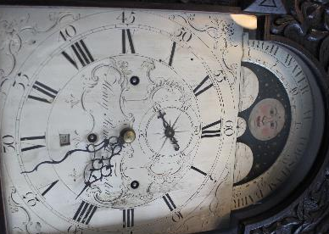
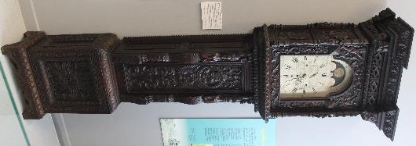
In our Wool Trade Gallery we have a long case clock made by Henry Rendell of Tiverton, c. 1767-1814. This shows the high water at Topsham Bar and may have been owned by a local merchant who exported goods from Topsham. The clock plays a tune every three hours (9:00, 12:00, 3:00 etc.).
Henry Rendell was a renowned local clock maker, and took over the shop used by the Thorne family of clock makers on Fore Street (where the HSBC bank is today). The highly decorated case is of a later date, probably Victorian.
Another recent acquisition in the Wool Trade Gallery is a Tillet cloth or wrapper, shown on the front of the newsletter. This features the East India Company coat of arms and the merchant’s mark for Thomas Fox of Coldharbour Mill, Uffculme, c.1821. It would have been used to wrap cloth for export. The East India Company exported a fabric called Long Ells, made in the West of England, to China. A smaller amount went to India. It was a coarse version of the kersey cloth for which Devon was famous. Thomas Fox was apprenticed to his grandfather Thomas Were, a woollen merchant from Wellington (we have one of Were’s cloth seals on display as well). Fox took over the family business in 1796, purchasing and renovating Coldharbour Mill. He died in 1821. It’s possible that the wrapper was not used because Thomas Fox had recently died, and his sons had yet to decide on the new name for the company (Fox & Sons).
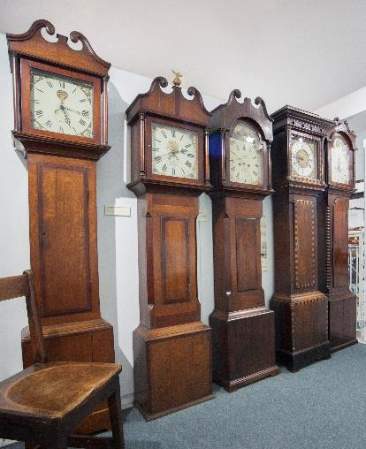
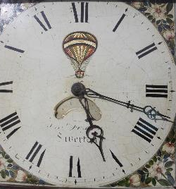
Another recent addition to our clock collection is a long case clock made by Thomas Foster, c. 1821-1850. Thomas Foster was a watch and clockmaker based on the north side of Fore Street. He was also an agent to Universal Life Assurance Company, auctioneer, appraiser and dealer in game.

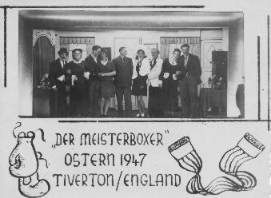
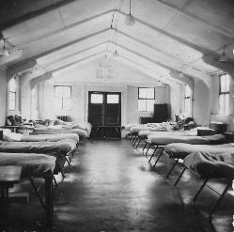
The face of the clock unusually depicts a hot air balloon. Martin Dunsford recorded in his history of Tiverton, that the first hot air balloon ascent in Tiverton took place in May 1788. Mr West ascended from the Bowling Green (now the Pannier Market area) in a gas-filled paper balloon (about 50 feet in circumference and filled with gas ‘from spirits of wine’) and managed to travel to near Bickleigh. This was only a few years after the first hot air balloon ride in Paris in 1783.
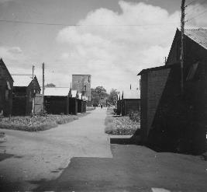
Finally, we have been pleased to receive some very rare photographs of Tiverton’s World War Two Prisoner of War Camp taken in 1947. They were acquired from the family of Fritz Wieser, who was originally from near Essen in Germany. Following the war, Fritz moved to Canada where the family stayed. The photographs were taken within the camp itself, and one even shows the interior of one of the huts. They also depict various concerts and social events that were held there. In 2018 we acquired a copy of the newspaper produced in the camp in 1946, and successfully appealed for more information about former prisoners of war. We are still very keen to collect anything with a link to the camp, especially pecking chicken toys which we know were made by some inmates. The photographs will be added into the museum’s permanent display about the Second World War.
Pippa Griffith

Exploring Hidden Multicultural Histories in Tiverton
Britain has been fortunate to benefit from the movement of people from all over the world. Tiverton’s history is both long and complex, with people from all parts of the globe drawn to the town for many reasons. Our project called ‘Telling Our Stories, Finding Our Roots’, part of a wider Devon project, builds on an earlier project focused on Exeter. It will explore the stories of Black, Asian and other minority ethnic people in Tiverton. The project will enable us to delve into some of the most intriguing, difficult and diverse stories of our past. We will celebrate the benefits of our multi-cultural past and present.
The project is led by Lizzie Mee, Community Heritage Co-ordinator (in Tiverton). It is being developed by Devon Development Education, an education charity, reg. no. 1102233, with an office base in Exeter, and builds on an earlier project of the same name run in Exeter. This charity works with schools and communities, aiming to help children and people of all ages to understand the big issues in the world and their involvement in them; make links with the ‘global village’ within and outside of Devon; and work together for a more just and sustainable world.
Volunteers have already joined the team to start work on researching several of our main themes. These include the life of John Gabriel Stedman and his family, including his mixed-race son called John, a young man who was bought out of slavery (in Surinam) by his father to live in Tiverton. Tiverton’s place in the cloth trade will be explored as well as the people who have travelled here as a result of Britain’s colonial past. We’re also starting to explore the impact of black GIs from World War II in the town as well as prisoners of war. Other stories include people who have come to Tiverton to work, greatly enriching the town with their music, food and ideas. Jeremy Salter’s article, which follows, shows that our work needs to include those who came to Tiverton for a British education during the days of the British Empire and those who continue to seek a British education at Blundells School and why.
After only a short period of research we have already found stories of integration and conflict, as well as more personal stories of people falling in love, or building successful businesses. What we have found is the only tip of the iceberg, so there is much more to do! For example, we would like to have volunteers who are interested in finding out about the restaurant trade, and the people who are behind our multi-cultural food industry.
The project is not just about exploring stories from the distant past. We would like to hear from anyone who has a family story to tell or something they would like to share about their own multi-cultural past. If you are interested in volunteering with us, I am at Tiverton Museum every Monday, or just email me (details below).
You can do research at the museum or in your own time at home, depending on what you are interested in. The project involves researching, interviewing people and storytelling, and will culminate in an exhibition at the Museum, as well as other events. Full training will be given, and Lizzie Mee will help you throughout. If you know someone who might be happy to share their story, please pass on these contact details.
Lizzie Mee: lizzietosfor@gmail.com or 07932776498.
Devon Development Education: 01392 438811, dde@globalcentredevon.org.uk, www.globalcentredevon.org.uk.
Lizzie Mee

Neil Ghosh and the Jewel in the Crown
When I was Housemaster of Old House at Blundell’s, my wife was contacted by the biographer Hilary Spurling to ask if we possessed a photograph of Neil (Neel Baron) Ghosh, an Indian member of the house during the 1930s. We were able to provide her with a 1937 group photograph, and, from this she was able to extract the picture of Neil which is included in her fine biography ‘Paul Scott – A Life’ (Hutchinson, 1990).
The acclaimed novelist, Paul Scott (1920-1978) won the Booker Prize for ‘Staying On’ in 1977, but his name will always be associated with the four novels set in India during the 1942-1947, known as ‘The Raj Quartet’. These were turned into an acclaimed television series, ‘The Jewel in the Crown’ in 1983, a key figure in these novels being Hari Kumar.
When the biography was published the author sent us a complimentary copy and, on reading it, we soon realised why Neil was such an important figure because it revealed that Paul Scott had closely modelled Hari Kumar in the novels on Neil Ghosh, with whom he became acquainted in Calcutta. Like Neil Ghosh, Hari Kumar had been educated in an English Public School, in his case the fictional Chillingborough, where he was named Harry Coomer, and, like Neil, he had been forced to return to India, in his case because of the bankruptcy of his father. Both sounded, behaved and thought of themselves as English in everything but the colour of their skins, returning home to find themselves ‘too Indian for the English and too English for the Indians’ and both struggled to find their place in an India they no longer knew, being rootless figures caught between two cultures. In the novels Hari had a tragic affair with an English girl, Daphne Manners, and he was, following a trumped-up charge of rape, brutally treated, being interrogated, imprisoned, sexually humiliated, beaten and tortured by Ronald Merrick, an English policeman, who resented his deferential English manner.
Neil Ghosh was the eldest son of an officer in the Indian Medical Service, Lieutenant-Colonel Albani Mohan Ghosh, who had been trained at Edinburgh and who made an arranged marriage to his mother when she was ten years old. They had five children and, being an enthusiastic anglophile, he was very keen that they should have an English education. When the three eldest children were old enough, they were sent as boarders to English schools, Neil and his brother Pushkar Baron Ghosh to Wolborough Hill, a preparatory school in Newton Abbot, and later to Blundell’s, while his eldest sister Uma, went to Roedean.
Subsequently, the whole family moved to a large house near Newton Abbot, an English governess and servants being provided for the two youngest children. Hilary Spurling claims that ‘The Colonel’s family were the only Indians in Devon, perhaps in the whole West Country, and certainly the only brown faces the local people had ever seen’. Neil’s mother, Sailo Bala Ghosh, who spoke little English, became isolated and very unhappy in what she felt to be an alien environment, and, sadly, both parents died in 1935, Lt Colonel Ghosh dying at Ahmedabad at the age of 46.
Being the eldest son Neil assumed responsibility for his orphaned brothers and sisters whilst continuing his education at Blundell’s, where he was, notably, a keen cricketer and sportsman. He left school in 1937, and, by 1939 family funds were running low, war was looming in Europe and an uncle ordered the remainder of the family to return home to India. Pushkar, then in his last year at Blundell’s, had to give up a scholarship to Oxford and Uma was fearful about the transition from Roedean to a life of arranged marriages and subservience. Hilary Spurling states that it was ‘a traumatic cultural shock from which most of them never fully recovered’.
On returning to India in 1938 Neil was found a place in Bird and Co, one of Calcutta’s great British mercantile houses, and he was initially very successful, being rapidly promoted, and, when Paul Scott met him, he was head of one India’s biggest coal suppliers. He was, for a while, able to lead a lavish and extrovert lifestyle, but he had no Indian friends and support drained away as his English acquaintances left one by one.
Following independence, the new government introduced a programme of compulsory Indianisation for British firms and ‘The education for which the Ghosh family had paid so dearly – Neil’s attitudes, his achievements, his manner, even his voice – all counted against him’ (Hilary Spurling). He was demoted and, in 1965, he was forced to resign. He became bitter and depressed, a heavy drinker, and, a disillusioned man, dying in Calcutta just before his 60th birthday.
As a housemaster I have looked after students from many countries and have often pondered as to why parents have sent their children thousands of miles to an alien environment of spartan living conditions, compulsory games and religion and often archaic traditions, while, in some cases, their children have rarely returned home for many years, being looked after by guardians during the school holidays. As the number of foreign students in boarding schools has increased, life for them has undoubtedly become much easier and many have benefitted greatly from the experience. But, as the story of the Ghosh family shows, the effects of a public-school education was, and sometimes still can be, disastrous for those who receive it!
Jeremy Salter
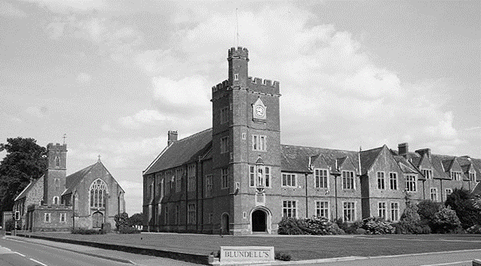
Lorna Doone 150 years on
Richard Doddridge Blackmore (1825-1900) published his third novel, Lorna Doone, in 1869. Unlike his others novels and extensive poetry, it has remained in print to this day. In the preface to the first edition, he describes it as ‘a romance, because the incidents, characters, time and scenery, are alike romantic’. In this he was a pioneer of a movement in fiction which continued with Robert Louis Stevenson. Nevertheless, the setting is historical, and in this he followed the pioneering fiction of Sir Walter Scott who inspired not only English but European writers, including famous Russian writers.
Lorna Doone is set in the wild country of seventeenth century Exmoor and begins with the description of the hero and narrator, John Ridd (a very common Exmoor name), attending Blundells School in Tiverton, founded about sixty years earlier by the executors of Peter Blundell, clothier, on the south side of the river Lowman. It is based on legends of the Doone outlaws, a cadet branch of a noble Scottish family (Doune), who were based in the East Lynn valley in western Exmoor at that time. The vivid and lengthy descriptions of Exmoor and the detail of the local dialect reflect the Exmoor of Blackmore’s childhood, part of which was spent living with his grandfather, a clergyman, roaming the valleys of central Exmoor, around Badgworthy Water.
Blackmore’s mother died a few months after his birth from typhus. His father, a clergyman, was unable to keep the young family together. The children were sent to live with relatives in Neath and in Devon until their father remarried, became Rector of Culmstock and was able to reunite the family. Richard was sent to Blundells School, Tiverton, the leading grammar school in the West Country, where he lodged in a house off Gold Street with the future Archbishop of Canterbury, Frederick Temple, who bullied him mercilessly. He became an outstanding scholar in classical studies. He won a scholarship to Exeter College, Oxford, gaining his degree in 1847, and becoming a barrister in the Middle Temple, London.
The preface to the first edition stresses that, because the novel is based on local historical myth rather than fact, it cannot be described as a historical novel, although it does include the historical event of the Monmouth rebellion and its aftermath in the West Country. Woven into the fabric of the novel is the autobiography of Blackmore’s childhood, and many theological, social and political issues current in the Victorian era. Among these are the Protestant Christian ethic of hard work, personified by John Ridd himself as a yeoman (freehold) farmer, with his stress on his own size and strength. John Ridd reiterates his father’s and his own position in the parish as pillars of the community, depicting the philosophical movement known as ‘muscular Christianity’. This philosophy is overt in Thomas Hughes’ Tom Brown’s Schooldays (1857) and Charles Kingsley’s novels (1848 to 1873). It was characterised by a belief in patriotic duty (depicted by John Ridd’s loyalty to the king during the Monmouth rebellion), self-discipline and self-sacrifice, manliness and strength, all characteristics personified by John Ridd.
The rising importance of a good education in the Victorian era is depicted by John Ridd’s attendance at Blundells School. He is obliged to leave before he has completed his education as a consequence of the death of his father at the hands of the Doones on one of their regular raids into the Exmoor countryside to steal cattle, sheep and local women. He becomes the new head of the household on Ridd farm, the largest and most prosperous in the parish of Oare.
The role of women is explored in the novel. While the traditional view of women at the heart of the home is depicted by John’s sister Annie, the emergence of educated women is portrayed by his sister Lizzie. Lorna herself represents young women imprisoned in a feudal role, as aristocratic chattels with no rights, represented in the novel by a fabulous necklace. She escapes from this position by refusing to marry Carver Doone, grandson of the head of clan Doone, Sir Ensor, and fleeing to the Ridd farm at Oare with John. Lorna, unbeknown to herself, is the heiress of the Doune estate and dukedom in Scotland, inherited by Sir Ensor’s older twin brother. She was kidnapped as a young child by Sir Ensor’s men while crossing Exmoor with her mother and brother who were killed. Her marriage to Carver, planned by Sir Ensor, was intended to re-unite the two branches of the family and bring the estate to the descendants of both brothers.
The failure of the aristocratic Doone family to regain their patrimony, and the rise of Ridd family as proud yeoman farmers touches on social change - the decline of the aristocracy and the rise of the middle class in England in terms of both wealth and power. While the traditional source of wealth was land, often held by clergymen as well as nobles and yeomen, new wealth was being created in Victorian times through the industrial revolution. Blackmore’s attitude to this new, urban-based wealth was ambivalent due to the social and environmental issues arising from industrial labour conditions and the squalor of urban living.
In Lorna Doone, John Ridd is forced to visit London and stay there for several months. The city is seen as a dirty and unhealthy place to live, and the countryside extolled as fresh and clean. Blackmore lived in London while practising as a barrister but was unable to pursue this career due to epileptic fits, possibly caused by injuries to his head when he was bullied at school. With a legacy from his uncle by marriage, Rector of Neath in South Wales, with whom he had spent part of his childhood, he was able to purchase 16 acres of land in Teddington, then a village outside London, on which he built a house and created a market garden, sending fruit to Covent Garden market.
150 years on from the publication of Lorna Doone, many of the issues addressed in the novel remain, but take very different forms today. Social issues remain high on the political agenda, and although modern churches remain active in efforts to alleviate them, the leading role is now part of the secular political and professional agenda. The role and status of women in the workplace has indisputably improved, but their choice to focus their lives on home and family has become limited by the need for both men and women to work to support their families, while the right of men for leave from work to care for family members has only marginally improved. The right to a good education for both men and women is now assumed but not always achieved. The right to equal pay for men and women at work doing the same class of job remains an issue in some industries and offices.
In the seventeenth century, most of the population lived a rural life. By the nineteenth century, Blackmore’s lifetime, a far greater proportion of the population lived in urban areas, and rural depopulation through young people moving to towns for work or emigrating to the British colonies was slowly destroying the traditional rural life depicted in the novel. Today over 90% of the population in England is urban, and environmental issues are largely driven from an urban perspective on life. The novel Lorna Doone is loved and read for its romance, but the issues it confronts on changing ways of life, on the role of women in the society, and on education, religion and environmental issues, are ones we grapple with in a different form today.
Fern Clarke
Note from the editor: We shall be assembling the next newsletter in April 2020. Contributions related to Tiverton and the West Country are welcome and should be sent to the Chairman, on jeremysalter2014@gmail.com, by the end of March 2020.

Restoration of the Greenway Chapel, St. Peter’s Church
The St. Peter’s Quinquennial Inspection of 2013 pointed out essential restoration works for the Greenway Chapel concerning most critically, the south-facing windows. The original stone mullions had been replaced with reinforced concrete and over time, the iron reinforcing rods had rusted, “blowing out” sizeable chunks of the mullions and thus weakening the window structure on the side which receives the brunt of the wind and rain. As many other elements of the chapel needed repair, it was decided to undertake a restoration project to complete in the chapel’s 500th year, 2017.
Prior to beginning the work, an Historic Building Recording was performed by Richard Parker, comprising a complete survey of the materials making up the chapel, identifying the types of stone and determining which stone represented the several restorations that have been performed over the centuries, and specifically identifying the original 1517 material that still remains. Photographic records were created along with detailed architectural drawings. A record was made of the materials used in prior restorations so those used in 2017 could be appropriately complimentary.
The exterior was first cleaned with super-heated steam containing a biocide to reduce the mould. This process highlighted a need to replace some of the material from a 1980s restoration. Then the long and detailed process began of filling cracks, carving and replacing several stones in one pinnacle that was in danger of collapse, replacing the mullions and re-leading the south windows, and restoring some of the exterior carvings. The final step for the exterior was to apply a weather coating that would protect the base stone over the coming decades. Internally, cracks were filled and all paint was removed and replaced with proper lime wash. The dramatic ceiling pendants were re-secured along with a portion of the frieze surrounding the chapel interior walls.
The six-month project was completed in time for a 500th anniversary celebration in October, bringing together those directly involved with the work, and giving St. Peter’s an opportunity to express our gratitude for the loving and professional approach taken by all. Elizabeth Fathi, Chief Executive, Tiverton Almshouse Trust, spoke of the impact John Greenway and other Tiverton cloth merchants on the economy of the town and of the close ties between the town, St. Peter’s and the evolving textile industry.
This project was nominated for the SPAB John Betjeman Award given annually to exceptional restoration and conservation projects to structures of national interest and importance. The Greenway Chapel was among the final four projects that were short-listed. Alas, victory was not ours, but we can be greatly satisfied to know that we have preserved and protected one of Tiverton’s and Britain’s architectural treasures. And perhaps it was just in time since John Greenway himself tells us,
“whilst we think well and think t’amend
time paffeth away and death’s the end”.
On that encouraging note, anyone wishing to see or hear more, please contact Bill Zarrett, Churchwarden (william_zarrett@yahoo.com).
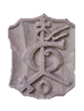
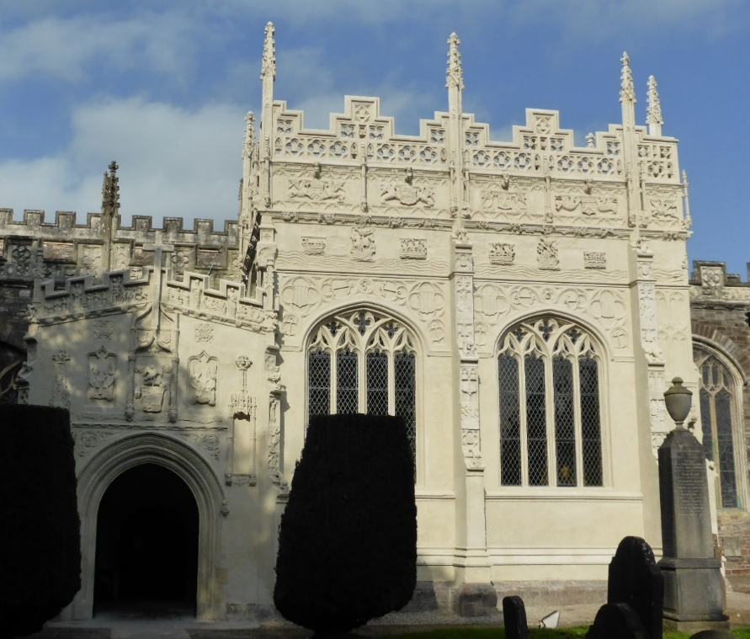
Bill Zarrett

The Restored Front of the Greenway Chapel, St. Peter’s Church with John Greenway’s merchant mark in the top left corner

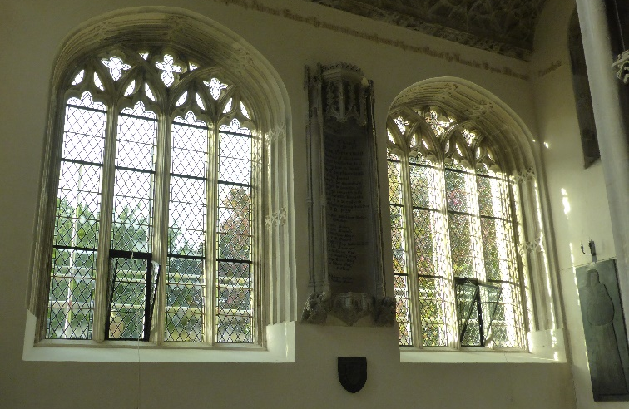
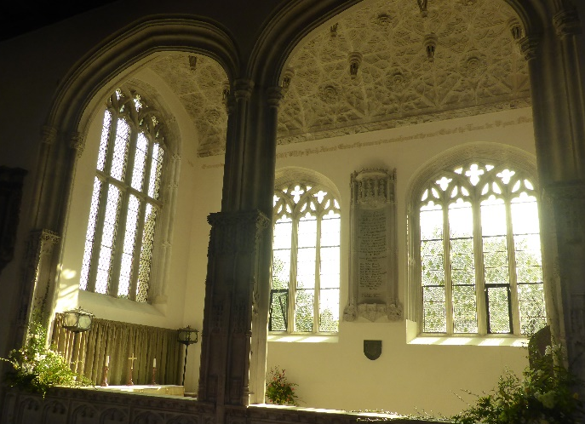

The interior of the restored windows, with the brass of John Greenway in the bottom left of the right-hand picture

